Let’s Encrypt
# Source: AI Source: Provided by: [Data Path: Persons Table -> ID Column: 1, Name_En Column: Motasem Essam] -> From: [ChatGPT] on [1/18/2026]
Let’s Encrypt is a global / well-known Certificate Authority (CA) that provides free, automated SSL/TLS certificates for securing websites with HTTPS.

🌍 What is Let’s Encrypt?
# Source: AI Source: Provided by: [Data Path: Persons Table -> ID Column: 1, Name_En Column: Motasem Essam] -> From: [ChatGPT] on [1/18/2026]
- A public (global) CA
- Trusted by all major browsers and operating systems
- Operated by the Internet Security Research Group (ISRG)
- Mission: Make HTTPS free and accessible for everyone

🔐 What Let’s Encrypt provides
# Source: AI Source: Provided by: [Data Path: Persons Table -> ID Column: 1, Name_En Column: Motasem Essam] -> From: [ChatGPT] on [1/18/2026]
SSL / TLS Certificates (HTTPS)
Used to encrypt traffic between users and websites.
- DV only (Domain Validation)
- No Organization or Extended Validation
- Fully automated issuance & renewal
Example:
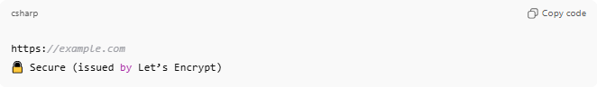
https://example.com
🔒 Secure (issued by Let’s Encrypt)

🛠️ How it works (ACME protocol)
# Source: AI Source: Provided by: [Data Path: Persons Table -> ID Column: 1, Name_En Column: Motasem Essam] -> From: [ChatGPT] on [1/18/2026]
- Website proves domain ownership
- Let’s Encrypt automatically issues a certificate
- Certificate is installed on the server
- Auto-renewal every 90 days

📍 Where it’s used
# Source: AI Source: Provided by: [Data Path: Persons Table -> ID Column: 1, Name_En Column: Motasem Essam] -> From: [ChatGPT] on [1/18/2026]
- Personal websites
- Blogs
- Startups
- APIs
- Cloud & container environments
- Reverse proxies (Nginx, Apache, Traefik)

✅ Advantages
# Source: AI Source: Provided by: [Data Path: Persons Table -> ID Column: 1, Name_En Column: Motasem Essam] -> From: [ChatGPT] on [1/18/2026]
- 100% free
- Trusted globally
- Fully automated
- Easy to renew
- Massive adoption across the web

⚠️ Limitations
# Source: AI Source: Provided by: [Data Path: Persons Table -> ID Column: 1, Name_En Column: Motasem Essam] -> From: [ChatGPT] on [1/18/2026]
- No OV or EV certificates
- Short validity (90 days)
- Not ideal for code signing
- Limited human support

🔒 Security details
# Source: AI Source: Provided by: [Data Path: Persons Table -> ID Column: 1, Name_En Column: Motasem Essam] -> From: [ChatGPT] on [1/18/2026]
- Uses strong cryptography
- Supports modern TLS standards
- Provides certificate revocation (OCSP)
- Backed by major tech organizations

🆚 Let’s Encrypt vs DigiCert
# Source: AI Source: Provided by: [Data Path: Persons Table -> ID Column: 1, Name_En Column: Motasem Essam] -> From: [ChatGPT] on [1/18/2026]
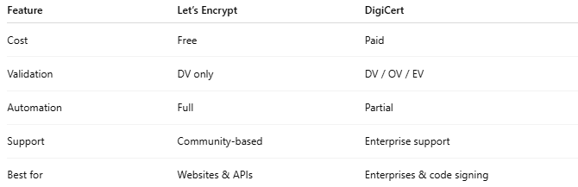
Feature | Let’s Encrypt | DigiCert
Cost | Free | Paid
Validation | DV only | DV / OV / EV
Automation | Full | Partial
Support | Community-based | Enterprise support
Best for | Websites & APIs | Enterprises & code signing

🧠 When to use Let’s Encrypt
# Source: AI Source: Provided by: [Data Path: Persons Table -> ID Column: 1, Name_En Column: Motasem Essam] -> From: [ChatGPT] on [1/18/2026]
Use Let’s Encrypt if:
- You need HTTPS encryption
- You don’t need identity verification
- You want zero cost
- You want automatic renewals

Quick summary
# Source: AI Source: Provided by: [Data Path: Persons Table -> ID Column: 1, Name_En Column: Motasem Essam] -> From: [ChatGPT] on [1/18/2026]
- Type: Global / Public CA
- Cost: Free
- Validation: Domain-only
- Best for: Most websites and APIs

